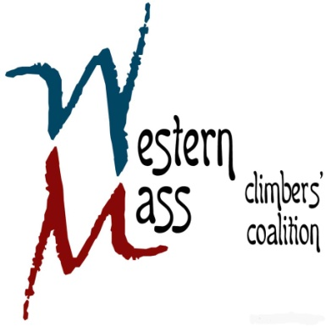

**1st Quarterly Meeting Agenda**

**Thursday February 26th, 2015 / 7:05 PM / CRG Hadley**

**Financials** (*15 mins*)

* Current standing
* Membership update

**Silent Auction** *(30 mins)*

* Pre-event planning
* Delegating responsibilities
* Other

**Farley Project Update** *(15 mins)*

* AMC/NET trail preservation project

**Access** *(15 mins)*

* Future projects update

**Open Forum** *(15 mins)*

* Any remaining items